

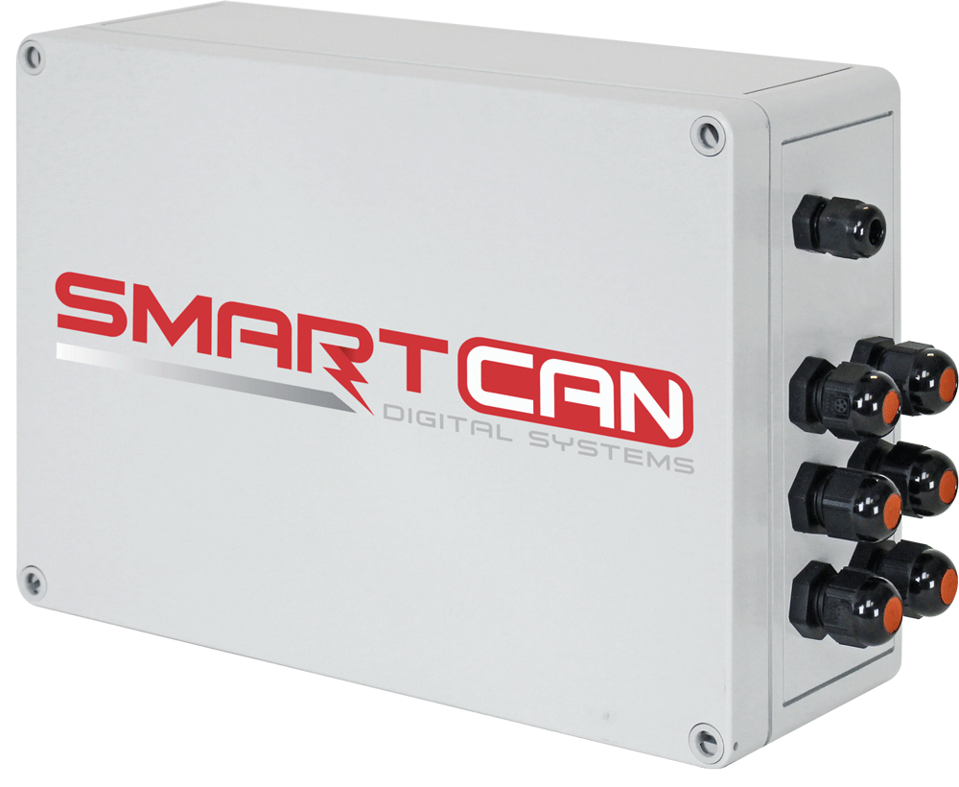

SmartCan Digital Conversion System Specifications

GENERAL PROVISIONS:
The system shall digitize any existing analog scale system.
The system shall digitize the output signals of two or more independent load cells and send the digitized data signals to an indicator.
The system shall have the capability of digitizing the output signals of up to 32 analog load cells.
The system shall have the ability to “daisy-chain” multiple SmartCan devices together to best suit the number of load cells in a weighing system.
The system shall utilize the internationally-standardized CAN (Controller Area Network) serial bus protocol.
The system shall be compatible with both analog strain gage and hydraulic load cell systems.
The system shall comply with the appropriate speciﬁcations for a Class III / IIIL 10,000 division A/D Controller as speciﬁed by the National Institute of Standards and Technology Handbook44 and shall have an NTEP Certiﬁcate of Conformance attesting to that compliance.
The system shall comply with the appropriate specifications for a Class III 6,000 division Analog Data Processing Device as specified by the International Organization of Legal Metrology and shall have an OIML Certificate of Conformance attesting to that compliance.
The system shall be housed in an IP66 / NEMA 4 rated enclosure.
The system shall integrate with the weight indicator and display diagnostic and troubleshooting information on the indicator display in real time.
The system shall be compatible with Cardinal Scale’s patented SmartCal® software algorithm for scale calibration.
The system shall be compatible with Cardinal Scale’s iSite cloud-based remote monitoring system for load cells.
The system shall be compatible with Cardinal Scale’s NEST onsite diagnostic kit.
The system shall have onboard diagnostics that works in conjunction with the Cardinal 225D or 825D weight indicators. The diagnostic data shall include (but not be limited to) the following:
- Live (real time) Load Cell Weights
- Minimum and Maximum Load Cell Weights
- Deadload Shift (from original calibrated deadload)
- Individual Load Cell Signal in Millivolts
- DLC Controller Card Communication Error Count
- iSite Status of Last Connection
The system shall be compatible with copper wiring, glass fiber optic cabling, and wireless communications using the Cardinal SnapStream system.
The system shall have the ability to be powered by the CAN bus system, or be self-powered via an AC mains plugin.

